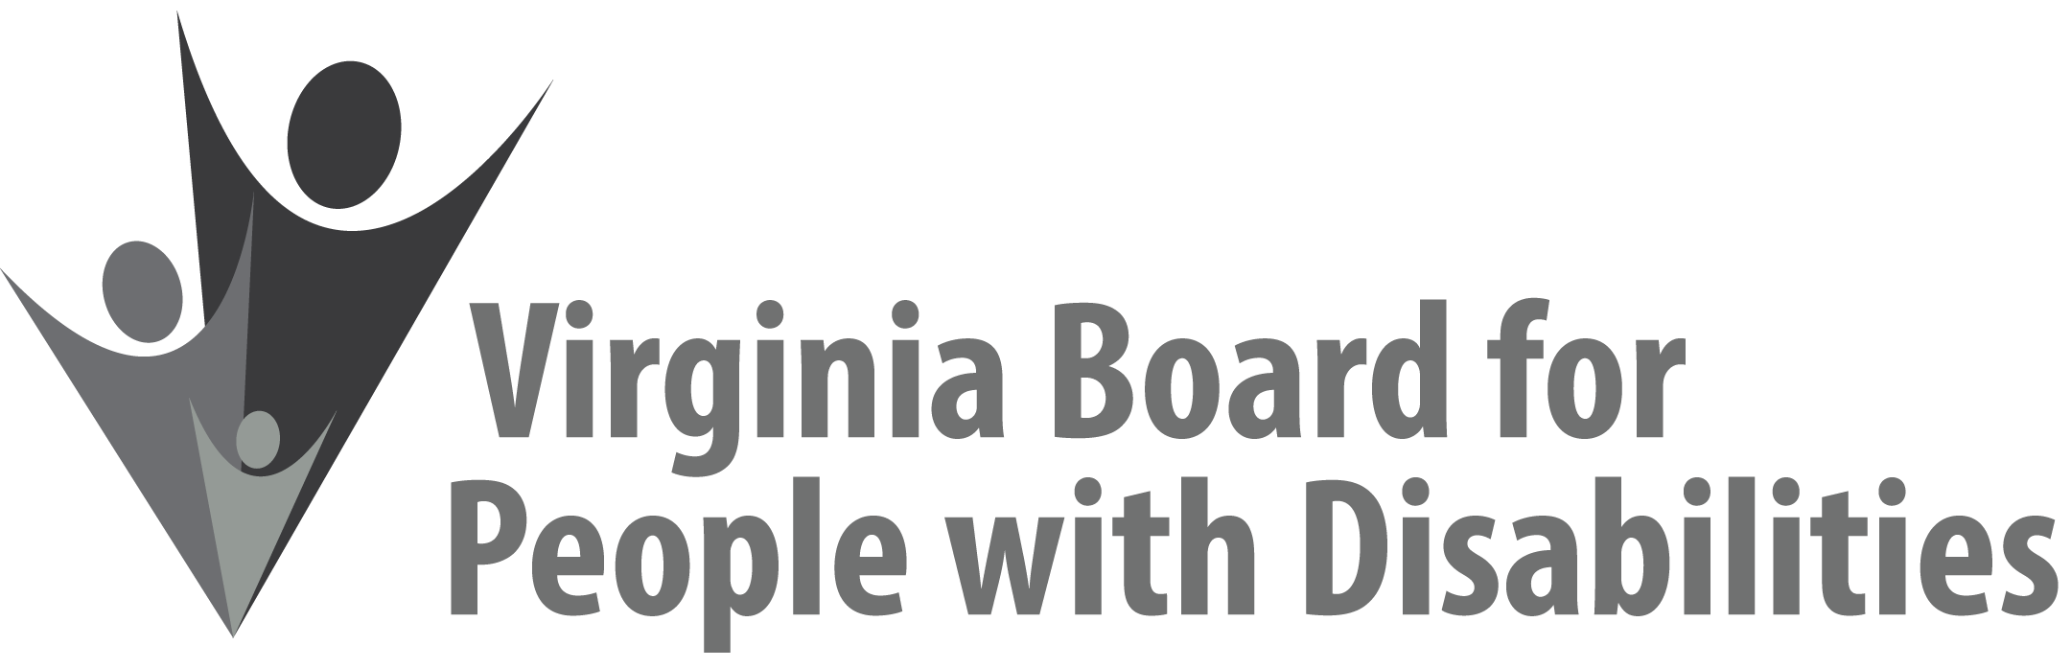

**Mission**To create a Commonwealth that advances opportunities for independence, personal

decision-making and full participation in community life for individuals

with developmental and other disabilities.

**Vision**Virginians with developmental and other disabilities direct their own lives

and choose how they live, learn, work, and play.

**STATE PLAN RETREAT AGENDA FOR WEBINAR #2**

**September 9, 2020**

**Virtual Data Walk: An Interactive Review of Board Activities and Current Data**

**12:00 pm - 2:00 pm**

<https://zoom.us/j/94526714497?pwd=OFVSeTEwNmh2Qno1aGQraitoSDA2Zz09>

Meeting ID: 945 2671 4497

Passcode: 891104

Dial by your location:

+1 646 558 8656 US (New York)

+1 301 715 8592 US (Germantown)

12:00 Recap and Overview of Today,Nia Harrison

12:10 Overarching Information (**Attachment SPB 2, SPB 3, and SPB 4)**, Nia Harrison

12:20 Four Breakout Room Sessions (**Attachment SPB 5 and SPB 6**)

* Healthcare & Quality Assurance, Nia Harrison
* Community Supports & Employment, Teri Morgan
* Housing & Transportation, Jason Withers
* Education & Self-Advocacy, Linh Nguyen and Penni Sweetenburg-Lee

1:40 Questions and Discussion (**Attachment SPB 6**), Nia Harrison

2:00 Adjourn

Please note that the final portion of the State Plan retreat will occur on September 17, 2020 from 9:00 am – 5:00 pm. Members of the State Plan ad hoc committee will meet at that time to draft goals, objectives, and activities for the next State Plan. Materials for this meeting will be sent out separately in the coming weeks. If you have not been informed that you have been selected to serve on the ad hoc committee, but are interested in doing so, please contact Nia Harrison at [Nia.Harrison@vbpd.virginia.gov](mailto:Nia.Harrison@vbpd.virginia.gov) or 804-786-7333 as soon as possible.